2021 DiscoverSTEM Webpage Instructions

**Introduction**

Each Spring, the Mathematics Education Association, a BYU student club of future mathematics and elementary school teachers, puts on a large fair for 6th, 7th and 8th grade students to introduce them to the wonderful and engaging worlds of Science, Technology, Engineering, and Mathematics. We call it the DiscoverSTEM fair. The fair has about 50 booths in the Wilkinson Center and about 500 students come and engage for about 3 hours. They love it!

However, due to the worldwide COVID-19 pandemic the 2020 and 2021 DiscoverSTEM fair have been cancelled. In order to keep promoting interest and knowledge about STEM fields we are moving the fair onto a website and need help creating interactive activities and learning experiences to put on the website. The idea is to take the activities like the ones students could experience at the booths at the fair, and make a webpage that helps them engage in the same kind of activity. The website would have a lot of individual pages, one page for each activity. Where do you come in? We need you to make an engaging and interesting activity that we can put on the website!

***We need all materials submitted by January 31st, 2021.***

**Step 1: Find an Activity/Topic**

The best booths are ones where students could engage with a topic, a device, a phenomenon, etc. Try to find something that students can actually do something, try something, make something; or think about, solve, or figure out. Try to avoid a Wikipedia/textbook/lecture type presentation of a topic. We want activities that are fun to engage in and interesting for students.

A few rules of thumb for picking an activity:

1. The activity/topic should be focused on one idea/problem.
2. The student should learn something from the activity/topic about STEM. This might be about understanding an idea (why images are deformed when looking through water/glass), learning a skill (how to edit a webpage using “inspect element” on a browser), trying out/testing out a process (using the engineering-design cycle to solve a simple problem like making the most effective parachute out of a Kleenex tissue), practicing a skill (like problem solving), or introducing a resource (like an interactive website that allows students to make electrical circuits or learn/practice basic coding skills).
3. It should be something that a middle school/junior high student would find interesting/engaging.
4. The information should take about 4-10 minutes to read/watch/do. (At least the time that they spend reading/watching should not be more than 10 minutes, if there is an activity/problem that they are doing, the time can be longer).

Types of Examples (non-exhaustive):

* An engaging mathematics problem or puzzle. (For example, the famous Tower of Hanoi problem).
* Exploring and Understanding A surprising result (Did you know that at any time there are two points on earth that are exactly opposite each other that have the exact same temperature and air pressure?)
* A video illustrating Simple home experiments (safe experiments only).
* Games that students can play that require mathematical thinking/problem solving (accompanied with an explanation of things they are to learn, for example, how to use a particular problem solving strategy, or how to reason through moves).
* An explanation of how to do a simple and safe chemistry or science experiment with an accompanying explanation of the scientific/chemistry principle(s) involved.
* How-to instruction on how to make/engineer something.
* Interactive online applets/websites that allow students to explore/reason/argue in the nature of one of the STEM fields.
* A video demonstrating an experiment that students can not do at home and then have an explanation (on the video or after they watch the video on the website). **WARNING: Please try to avoid a webpage where all students do is watch a video. There are plenty of online videos illustrating STEM ideas. Be sure that you are using the video to get student engaged in something beyond the video. What are they going to do after they watch the video? How are you going to help them learn something from the video?**

The big point is to find something that students can engage in, learn from, and enjoy.

**Step 2: Register Your Idea**

To avoid multiple pages on the same topic/problem, we are asking that you register your idea. Please follow the link below and examine the list to see if your topic has already been claimed. If it has not, register your topic/problem by filling in a line of the spreadsheet with the required information.

https://docs.google.com/spreadsheets/d/1qUPHQzKFdSF1ZEovJGeuVeK0PC7WQlCZ5VSCGOCjKvg/edit?usp=sharing

**Step 3: Create/Gather the Materials**

Once you have your topic registered, create the materials that will be on your webpage. Think of creating your webpage as a small blog post. We will put it on the web, so you can submit your materials on a word document or a google doc (at least for most of your material). Write out the text of the webpage, embed pictures, include links to online videos or other pages, etc. Include instructions for the webmaster, for example, if your activity is a problem solving activity and you want the answer/explanation on another webpage so students won’t just look at the solution, explain that on your document. You can include links at the end of places where students might go to learn more (youtube videos, Wikipedia, etc.)

If you want an applet embedded (perhaps from geogebra) include the html embedding code in the document.

Some example writeups are located at the end of this document.

**Step 4: Submit Your Webpage Materials**

Email your webpage writeup and any other needed files to [mathedbyu@gmail.com](mailto:mathedbyu@gmail.com) . If you have materials that are too big to email (for example a video file), place it in a google drive folder (or other shareable folder) and send us a link that will allow us to access it.

***As a reminder, we need all submissions by January 31st, 2021, but submitting them early will help us immensely in getting the website up in time.***

Thank you for helping us out with this activity. If you have questions please email [mathedbyu@gmail.com](mailto:mathedbyu@gmail.com) or Dr. Douglas Corey at [corey@mathed.byu.edu](mailto:corey@mathed.byu.edu).

Examples

**EXAMPLE 1: The 4 Color Theorem**

There are 50 states, but you don’t need 50 colors to color the states on the map of the United States, since not all states are touching each other. How many colors do you need to color the map of the US so no two states that share a border are the same color? It turns out, all you need is 4. Not that many. What about all of the counties in the US? Still just 4. Mathematicians claim that for any map (meeting basic criteria) all you need is 4 colors. This is called the 4 Color Theorem and is one of the most famous theorems in mathematics

The basic criteria is that each region in the map (like a state or a county) needs to be a single region (not like a Michigan that has two separate parts), and it refers to a map on a plane, not on a “weird” shapes like a torus (doughnut shape). Also the regions of the same color can share a point (like the 4 corners of UT, CO, NM, and AZ), just not a boundary segment.

 

The white circle in the map on the left shows four regions that intersect at a single point, but this doesn’t violate the theorem because regions must share a non-zero length of boundary.

**Try It Out!**

Even though the 4 color theorem says that it is always POSSIBLE to paint a map with 4 colors and not have any regions of the same color share a boundary, finding out how to paint it might still be hard. You can give it a try. Below is an interactive applet that you can use to try to color a map with only 4 colors. Clicking on a region will change the color, clicking on it again will change the color again. The applet will tell you if you are successful!

[Below is the code that will embed the applet]

<iframe src="https://www.geogebra.org/classic/zadqespn?embed" width="800" height="600" allowfullscreen style="border: 1px solid #e4e4e4;border-radius: 4px;" frameborder="0"></iframe>

**Why is it True?**

I remember first hearing about this theorem, and thinking that it couldn’t be true. I thought “I will just draw a map that has 5 regions that all touch each other, that will disprove the theorem, because after coloring 4 regions, the 5 will have to be a different color since it is touching each of the other four!” Try doing what I did. Try drawing 5 regions so that each region touches all of the others. What happens when you get to the 5th region? If you are like me, you will quickly convince yourself that trying to disprove it through this method is futile.

**More Information**

The 4 color theorem is famous not because it is important, but because it was hard to prove. It was so hard that they had to use a computer to check a lot of cases of the theorem. It was the first theorem that was widely accepted that was proven by a computer (there are actually still some people that don’t accept it, because how can we be sure the computer actually checked them all, didn’t make a mistake, or there was an error in the code?). You can learn more about it by visiting the Wikipedia page (<https://en.wikipedia.org/wiki/Four_color_theorem>), or watching others explain it on youtube (for example, <https://www.youtube.com/watch?v=ANY7X-_wpNs> or <https://www.youtube.com/watch?v=NgbK43jB4rQ> )

**Example #2 How To Edit Existing Websites (Using Chrome)**

Have you ever wondered how someone changes websites to look the way they do? It is actually easy to make changes to a website and I am going to teach you how to do it! In the video below I show how to change text, change the size of text, delete features, and change the sizes of images. Most of all, you will learn how to access the code of any website that you can learn from and explore!

With these skills you can have fun with your friends by changing headlines! For example, here I changed a news article from KSL.com that I edited to show that the scoring rules of high school football is changing.



You can also feel better about your sports teams by turning their losses into fantastic wins! Did RSL really lose to Kansas City? It doesn’t look like it:

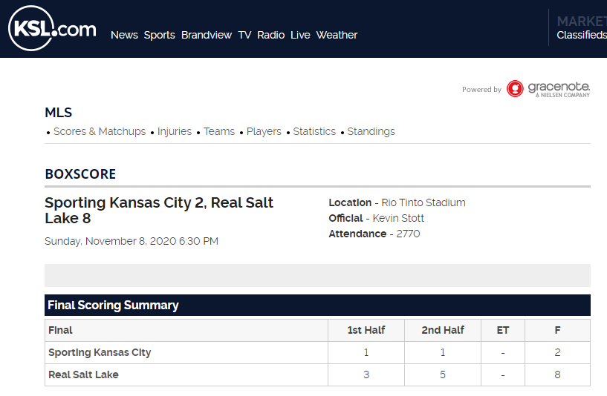

If you get good at this, next time someone wins an MVP award on ESPN, you can edit it so that it will be you!

[Embed Video Here. Link: https://youtu.be/3tLysjvc2X0]

More Information

HTML is language that websites use to share information with browsers. If you would like to learn more about the commands of HTML then you can take a free course online at codecademy.com (<https://www.codecademy.com/learn/learn-html>). Or use tutorials at w3schools.com (<https://www.w3schools.com/html/>). The latter has an entire library of HTML commands and explanations about how to use them.